How to Procrastinate
Everyone has those big, major papers and projects that no one wants to do. Contrary to popular belief, there is no need to stress over these projects and put in major effort early on: there is an easier way. Procrastination!
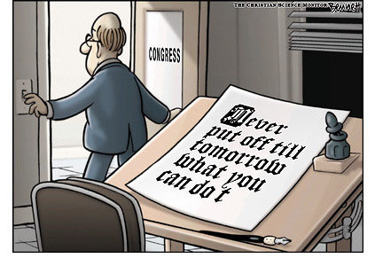
Procrastination is an art. It takes skill, practice, determination and dedication to not get your work done early. There are many different distractions you can use to keep yourself from working too hard. The most popular form on procrastination is the Internet. With millions of sites, games, articles, social networks and more, there are infinite hours of amusement provided at no cost to you on the Internet. Think of all the people you stalked on Facebook last night while avoiding studying for your calculus test tomorrow! You never would have learned that breast cancer finally took Paige’s mom, or that Julia got a new puppy, or that the local colleges all had their finals last week. You learn so much about so many people with every hour you spend on Facebook. So long as you steer clear of the games, you can at least appear to be productive! Of course, you could always turn to Wikipedia and learn something with the time you’re killing.
I remember the first time I ever procrastinated. I was in second grade, and our class was assigned a report on animals. It was the first report I had ever been assigned, and all I wanted to do was get to the library and start working on it. I was so excited to have a real report to do, just like the big kids!, that as soon as my mom picked me up from school, I begged her to take me to the library. She looked at me, puzzled, and asked when it was due. “One month,” I said, super excited to be getting my work done early. She kept looking at me, confused, and asked why I was rushing to get my paper done, “Hunny,” she said, “you have a long time to work on your report, you don’t need to start it now!” Just as any people-pleasing child would, I listened to my mother, and there began a life-long trend of procrastination.
…
There are many different forms of procrastination: unwillingness, fear, boredom, and lack of inspiration. No matter what your reason is, it is legitimate! Don’t let anyone tell you otherwise.
So sit back, relax, and take a break!
…
Procrastination can be broken down into four basic steps:
#1. Know what you have to do, and when you need to have it done by.
#2. Realize you don’t want to, are afraid to, or find any reason why you can’t do it now.
#3. Wait until the last minute to attempt your project or paper. There’s no kind of inspiration like last-minute panic!
#4. Do the best work ever.
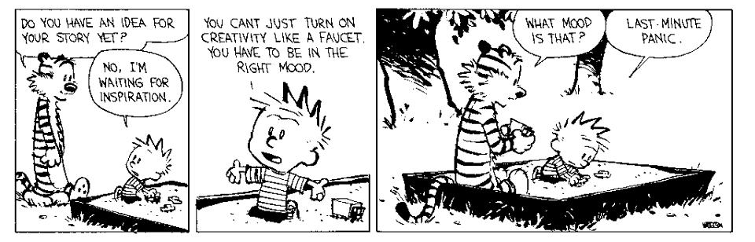
Now that you know the four basic steps of procrastination, let’s look more deeply into what needs to be done:
Eh, never mind, I’ll figure that out later.
Procrastination is foolproof and fail-safe. Save time and energy now, maybe lose sleep later. Overall loss? None! It is not as if you were going to bed before one AM, anyway. Don’t worry! You can do those dishes in the morning! Don’t feel like rotating the laundry? If it’s a hot day, those wet clothes will keep you cool! Or you could learn how to be Buddhist—the Dzogchen Buddhists make freezing garments steaming hot in minutes. You always accomplish more when you procrastinate, how do you think I learned that fun fact about Buddhists?
In high school, I realized just how terrible of a thing procrastination is. You sit at your computer, detesting the fact that you have work to do. You play games, and talk to friends, and then ten o’clock rolls around, shit hits the fan, and you stay up until you finish that stupid assignment that could have been done quicker (and better) hours before, when you were actually awake and fully functioning.
After I pulled my first almost-all-nighter in high school, I took my test the next day and failed. I realized after that before I tried to cram, I was probably prepared for the test enough. But, being sleep deprived was the part that really screwed me over. If I had slept normally that previous night, I would have gotten a B, easily, at worst a C, and my grade wouldn’t have hurt like it did with that ugly F.
Never since have I crammed for a test, written a paper only in one night, or tried to do most of a project in the days before it’s due. I know now to break up my studying and work, to think about my papers before I write them, finish my work projects ahead of time, and only do edits the night before things are due. Nothing comes out the way you want them to when you rush them; there aren’t enough hours in the day to be the perfectionist we all secretly are inside. Lesson learned, the hard way: procrastination is not the way to go.

